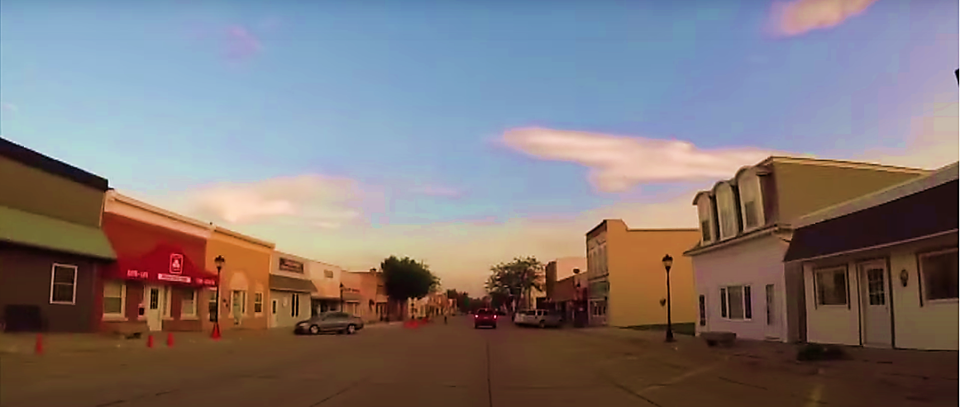



|  |
| --- |
| **Strategic Plan 2020-2025** |
| City of Neligh, Nebraska |
|  |
| Hexagon |

|  |  |
| --- | --- |
| Table of Contents  *Introduction 2*  *Infrastructure 4*  *Housing 8*  *Economic Development 11* |  |

***Improve Public Infrastructure***

***Improve the Existing Housing Market***

***Promote Commercial Development***

***Expand Recreational Attractions and Amenities***

***Continue Marketing Campaign***

***Enhance Community Beautification***

Introduction

Neligh’s Strategic Plan is a road map that helps guide the City through the next few years. The City’s Strategic Plan details where the City is going and how it plans to get there. Neligh will lead the way in building a solid community through financial health, community involvement, beautification and aesthetic improvements, additional amenities to serve all residents of all ages, improved public infrastructure, and upgraded public safety services to ensure Neligh is a community ready for growth.

The City of Neligh has spent significant time completing a planning process that includes documents completed to work together with the community to better prepare City leaders for action strategies and decision-making while moving forward with the community. The Comprehensive Plan serves as the community’s long-range plan providing goals and objectives for the next 5-10 years in Neligh. This Strategic Plan encompasses many of those same goals and objectives; however, this plan creates short-term goals for City leaders to work towards over the next five years. These goals are comprehensive in nature covering many different areas of the community, including streets and sidewalks, housing, and recreational amenities. The overall opportunities for success make these goals important, yet they will all require hard work, planning, and budgeting; many of the goals also require the support of the local community, as not all of these objectives can or should be completed by the City.

The city of Neligh is committed to ensure Neligh has a healthy future and to provide services residents have come to expect. The City will strive to effectively and efficiently develop and strengthen assets that contribute to a City that is a great place to live, work, and play.

Goal setting is an important step for any person, family, business, and even community. City leaders need to have clear long- and short-term goals, with strategies to reach those goals. However, these goals need to be comprehensive in nature, looking at every aspect of the community, and they must all align with a single vision for the future of the community. Personal and business goal setting is no different, it just may be more challenging at a City level because of all the varying aspects and components City leaders must constantly assess and direct in order to grow and change in an organized, efficient, and effective manner. The City of Neligh completed their Comprehensive Plan Update in 2014. This Plan allowed residents and community leaders to come together to create long-term growth and development goals for the City. The following is a list of the City’s long-term goals determined by residents and stakeholders:

These goals are a combination of information gathered from the public input sessions held during the planning process, research, and data analysis. The importance of these goals is that they are realistic in nature, but allow the community to continually have goals to strive towards over the next ten years. Long-term goals are important to keep in mind; however, feasible, short-term goals are crucial for stakeholders to accomplish. The City of Neligh utilized public input sessions, surveys, and data analysis from the planning process for the Comprehensive Plan as well as a meeting with the City staff to determine feasible five-year goals for the City to accomplish.

The Neligh Economic Development Office’s goals and objectives to accomplish over the next five years are included in this plan. Each goal of the Neligh Economic Development Office has a couple of objectives listed and it is the responsibility of the Neligh Economic Development Director and members of the Board to accomplish these objectives in order to reach their goals. These goals and objectives are included into the City’s overall Strategic Plan with the understanding that the City of Neligh, Neligh Economic Development Office, and the residents must all work together to reach their goals.

All of the above-mentioned goals are included in this Strategic Plan with projects separated into three different categories including infrastructure/public services, housing, and economic development.

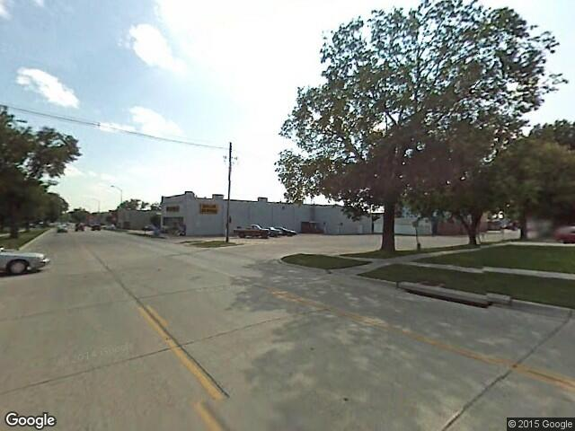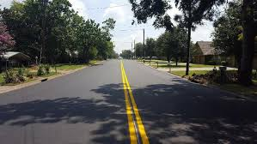

## Below is a list of goals concerning infrastructure improvements the City will accomplish within the next five years:

* Budget Annual Maintenance Fees;
* Water Distribution Improvements;
* Electrical Improvements
* Paving/Street & Sidewalk Improvements;
* Continual Enhancement of Technology Infrastructure; and
* Improve Recreational Amenities

The City understands the improvement of public infrastructure is an on-going process; however, this plan limits its examination to the next five years.

Infrastructure

*The City of Neligh will improve its public infrastructure through several phases of upgrades and improvements made in the next five years. Public services and infrastructure are vital to the community; Neligh wants to ensure its infrastructure and services provide for their current residents while having the ability to allow for growth, when needed. The City of Neligh will ensure public investment is utilized effectively by promoting balanced public investment and reinvestment opportunities in needed areas including public services and infrastructure that warrant a high quality of life for all residents. There are specific projects that the City would like to accomplish over the next five years in several phases from paving to water and recreational amenities to technological infrastructure needs.*

***Provide quality public services and infrastructure for current residents with the ability to expand, when needed, to meet higher demand due to growth in the community.***

## Budget annual maintenance funds for streets, water, & sanitary sewer;

All of the projects outlined in this section of the Strategic Plan are to be accounted for in the City’s Capital Improvement Plan (CIP). Because all of these public service and infrastructure needs are costly to the community, it is important that the City annually budget for general maintenance and improvement needs in order to avoid unnecessary surcharges for dilapidated infrastructure.

## Water distribution improvements;

The City of Neligh currently maintains Nebraska Public Water Supply No. NE3100305. The current system supplies water to its residents and businesses with four active groundwells, a 250,000 gallon storage facility, 740 metered services and approximately 14.47 miles of distribution main. The four active wells were constructed in 1957, 1973, 1984, and 2004. The average daily demand in 2018 was 750,000 gallons. The system has a maximum capacity of 2,266,000 gallons per day.

Recent work on the system has included the replacement of the four-inch water main and updates to variable speed controls on the west well and north well. The City plans to extend a water main to areas of new development or potential new development to provide City services to marketable areas for commercial and residential development. The City also plans to replace the water main from J Street to 11th Street and from Dogwood Lane to 1st Avenue.

## Electric improvements;

The City of Neligh is committed to making future improvements to the City’s electrical infrastructure including backfeeds to Blackburn Manufacturing, boring new underground lines between E and D Streets, and purchasing multiple vehicles to help with maintenance and repair.

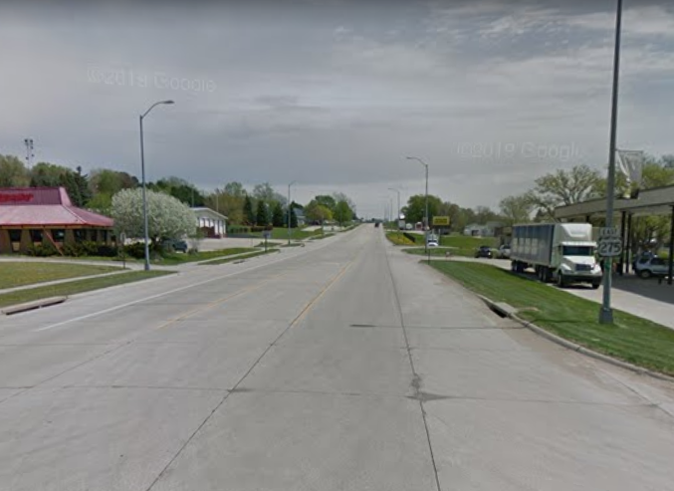

## Paving/street & sidewalk improvements;

There are roads that are in need of improvement, Neligh has a large percentage of concrete roads existing in the community. Although concrete is not the only street surfacing option, it has the longest life-span and needs less maintenance in comparison to other road surfacing types; therefore, concrete roads are a good investment for the future of the community. The City would like to eliminate the presence of any gravel streets in Neligh; however, short term goals will focus on the plan as outlined below.

This plan is in place to help guide achievable transportation development for the remaining five years. The projects include resurfacing 5th from L-K Street, 6th Street from J Street to H Street, 7 blocks North of WW, and 3 blocks of alley between M Street and Highway 275 from North 2nd Street to 5th Street.

In the Community Needs Assessment Survey, majority of community members feel sidewalk and street infrastructure is in below average condition. Updates will continually need to be made to improve these community aspects, and there are sidewalks that are in need of improvement in Neligh. Sidewalk inventory should be used to analyze areas in need of sidewalks and existing sidewalks in need of repair—the inventory would analyze each sidewalk and ramp (or lack thereof) to determine the overall needs for the community.

The City would like to improve sidewalks and make them ADA compliant; however, it should focus on the following short-term goals for the next 5 years. Creating a cost-share program between the City and the property owners to split the cost for the new improvements can entice residents to put forth some of their funds to assist in the development of ADA accessible sidewalks. The City should budget a set amount each year and residents could apply for funds out of that budgeted amount to assist in making these improvements throughout the City. Pedestrian accessibility throughout the community is important for residents, especially between key features in the City such as the swimming pool, school, the downtown district, medical facilities, public parks, Library, etc.

## Continual enhancement of technology infrastructure; and

Neligh now has four Fiber Optics providers including Great Plains, Nebraska Link, Plainview TelCo, and Stealth Broadband. Infrastructure for technology advancements is important in today’s economy; therefore, Neligh is truly preparing itself for a better position in the business growth department because they are able to offer technology resources that other similarly-sized communities do not have available. Continually improving this infrastructure and marketing it to potential businesses is important to the economic success of Neligh; therefore, the City will continue to work with the existing Fiber Optics providers to continue the improvement and expansion of this infrastructure.

## Improve recreational amenities

A full list of desired recreational improvements can be found in the Comprehensive Plan. The following list of projects was determined to be the priority goals for the community’s recreational amenities. Within the next five years, a pool study should be conducted in order to determine all of the issues present with the existing swimming pool. A cost-benefit analysis should be implemented to determine the best course of action moving forward including options of renovating/rehabilitating the existing swimming pool or constructing a new one.

Neligh has a variety of playground and picnic equipment to suit families and children of all ages. Existing park equipment will be periodically monitored to determine times for improvement or replacement to ensure Neligh’s parks are a safe environment for children to play. City stakeholders also discussed their desire for the City or Park Board to add additional playground equipment or create an additional “neighborhood” park on the other side of the community in order to provide a recreational amenity to close proximity to residential neighborhoods.

The Cowboy Trail and other trails are a large pull for recreational activity in the City as they provide a safe environment for exercising including walking, running, biking, and skating. The community expressed the desire to have a concrete hike/bike trail constructed around Penn Lake to serve as an additional recreational amenity. When marketing Neligh, a greater effort can be made to utilize the Elkhorn River for recreational purposes like tubing, tanking, kayaking, canoeing, etc. paired with these additional hike/bike trails in the community.

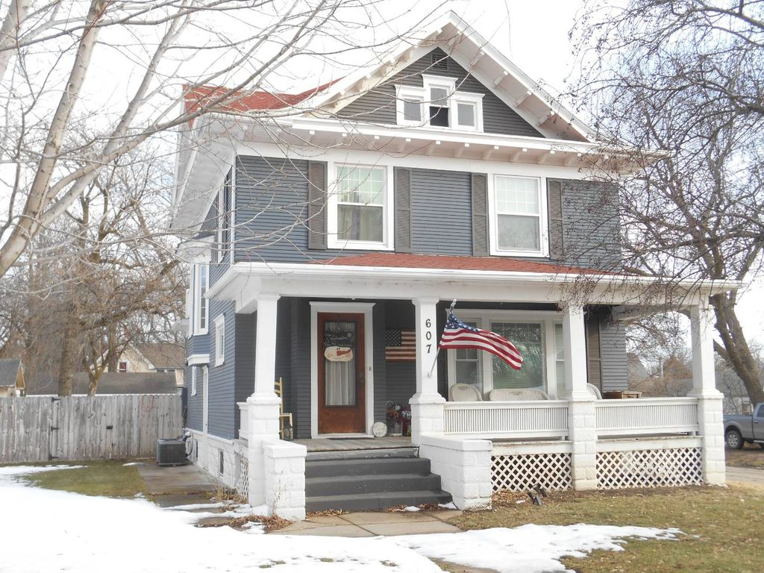

Housing

*Housing is a crucial piece to the prosperity of Neligh. Whether it is identifying needs for new market-rate housing or ways to encourage development of affordable housing options, Neligh must work to constantly assess and improve its housing market. In order to attract more people to the community, there has to be a supply of well-maintained, available, affordable, and safe housing. Projecting for future demand is an important, but sometimes difficult task when trying to promote growth in any community. Addressing the issues of old housing stock that does not meet the needs of today’s renters and buyers is also another challenge that faces City leaders. Community growth and revitalization can be made possible through the identification of housing needs in Neligh.*

***Improve the existing housing market because of its direct correlation to the success of the community by increasing stock, decreasing the amount of vacant dilapidated structures, and improving the exsiting stock to meet the needs of today’s renters and buyers.***

## The following is a list of the housing improvements the City plans to make over the next five years:

* Working with CORE Development Inc.;
* Work with Local Businesses to Determine Housing Needs;
* Demolition of Vacant, Dilapidated Structures;
* Downtown Housing Development Feasibility; and
* Housing Beautification

## Work with CORE Development Inc. to continue Owner-Occupied Housing Rehabilitation Programs;

CORE Development, Inc. is a regional agency that focuses on housing development and market improvements. CORE has been very active in the Neligh community, as well as many of the surrounding towns, for several years. CORE has Owner-Occupied Housing Rehabilitation grant funds available for low-to-moderate income households and the City will continue to partner with CORE to improve the local housing market, and will market and educate residents about the opportunities that CORE provides for Neligh.

## Work with local businesses to determine housing needs for employees;

The City should work with local businesses to determine housing needs for employees. Reaching out to local businesses shows the City’s support for them and opens the lines of communication between the City and employers to help provide beneficial information to one or the other. Some businesses may also be able to provide down-payment assistance for their employees, some may have purchased homes to rent to their employees, some businesses may even be able to help build spec housing to offer to new or existing employees. Investment Groups could also be created to build spec housing in Neligh; people are afraid to construct a new home on their own, if a group of residents was able to get the ball rolling, it may prove beneficial for existing and potential residents and provide some relief for the housing market.

## Demolish vacant, dilapidated structures;

All vacant lots and vacant, uninhabitable homes are properties that could be utilized for infill residential development. The City should access different avenues available to them to assist with the clean-up of vacant lots and uninhabitable properties. There is not a large amount of lots available for infill development; therefore, efforts need to be made to create more availability. Also, by cleaning up vacant lots and uninhabitable homes, the City will rid the community of unnecessary eye sores and safety and health hazards. There are a few ways to raze vacant, dilapidated properties including Tax Increment Financing funds, City-funded through acquirement of the property, or encouragement to the property owner through nuisance abatement. The City should budget a set dollar amount each year to go towards the acquisition and/or demolition of vacant, derelict homes.

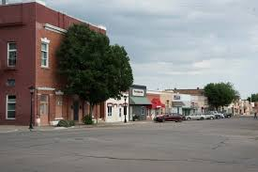

## Determine feasibility of Downtown housing development; and

Several residents and City leaders would like to see Neligh’s Downtown District extended to its fullest potential which would include utilization of the second level of many of the buildings in Downtown Neligh. There is a possibility to expand upon the rental market in Neligh’s Downtown buildings; however, a majority of these buildings were built 80+ years ago and would need to be assessed to determine the feasibility of a second story apartment development. The City of Neligh Economic Development Office will work together to commission a study on each of the potential buildings to determine a cost-benefit analysis for potential projects (s).

## Encourage housing beautification

The citizens of Neligh have voiced their concern for some sort of housing beautification effort through several mediums. The City and the Neligh Economic Development Office will look to develop some form of housing beautification program whether it be a beautification incentive, coordinating a volunteer effort, or encouraging the enforcement/extension of current nuisance ordinance.

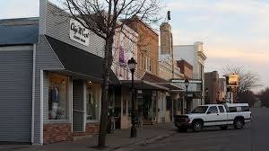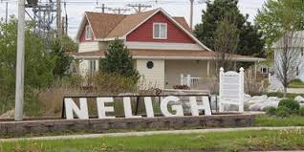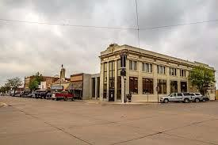

***Provide solutions and opportunites to showcase, enhance, energize, and grow the business community.***

Below is a list of goals to improve the Economic Development for the City of Neligh over the next five years:

* Youth Retention;
* Downtown Revitalization;
* Workforce & Continuing Education Development;
* Marketing Neligh;
* Developing Partnerships/Aligning Incentives;
* Continue Effective Business Retention & Expansion Program; and
* Business Attraction

*The City of Neligh will improve the business climate of the community by its focus and attention to sound economic development principals. The City will promote and emphasize private and public investment within the City’s Downtown and along its highway corridors. The goal of the City is to ensure a vibrant combination of prospering businesses, providing goods and services to the community, adding to the City’s quality of life, and fulfillment of resident needs.*

Economic Development

## Work for youth retention;

Attracting and retaining youth in Neligh is crucial to the future of the community. For this reason, the City—with the help of other groups/organizations like the Neligh Economic Development Office—will work closely with Neligh-Oakdale High School staff to ensure that Neligh’s youth feel at home and know they will have many opportunities here in Neligh if they choose to stay in the community or return after furthering their education. The different organizations within the City need to determine who is going to be responsible for different youth retention programs. A business tour and/or career fair to Juniors and Seniors would showcase the local businesses and potential career opportunities to N-OHS students. An entrepreneurship/apprenticeship program should be developed to help retain the youth in the community. Encouraging the youth to return to Neligh is crucial to the sustainability of the community; therefore, stakeholders cannot miss these opportunities to engage the youth while they are present in Neligh.

## Revitalize Downtown;

A thriving and active Main Street has long been a signal of a prosperous community. The City has recently been working diligently to improve the façades on multiple local businesses through the Downtown Revitalization Plan. Empty lots in the Downtown area should be filled by retail and/or basic service sector businesses. Downtown District appeal also needs to include filled sidewalks, decorated store fronts, and businesses that are open. These businesses should provide retail and entertainment that encourage pedestrian traffic throughout the day, evenings, and weekends. In forums held, the public discussed a desire for a clothing store/boutique, more dining options, and a coffee shop with free WiFi.

## Enhance workforce development & continuing education opportunities.

The Neligh Economic Development Office should continue to utilize Location Once Information Systems (LOIS)—an online database that the State of Nebraska, as well as many other states, utilizes to share current information with potential businesses. The City should market the community to potential business developers, and while the City is working to recruit new businesses, the City should also work with employers to determine what their need is for employees in order to recruit personnel to the community. Career fairs could be implemented in place for each business. Marketing and working to recruit potential businesses should be an on-going effort by the City, Neligh Economic Development Office, and local businesses.

## Marketing Neligh;

The City and Neligh Economic Development Office must continually market Neligh to current and future residents through the use of several programs. Neligh has conducted a Seasonal Photo Contest, “This is MY Neligh” marketing campaign, and a “shop local” campaign. Creating a community brand and marketing said brand to existing and potential residents and visitors is important when trying to develop an image. Social media marketing has been a huge draw to share information with existing residents while also marketing the community to potential residents and visitors, and the City and Neligh Economic Development Office should continue to market in this way as well as continue marketing in other aspects. Informing potential residents and investors about all of the positive aspects of the community, reminding local residents what it takes to be a self-sustainable community, and promoting and marketing Neligh’s assets, needs, location, funding sources/incentives, and land availability will be key to attracting private investment and should be an on-going focus.

## Develop strong partnerships/align incentives;

The City and the Neligh Economic Development Office have continued working to establish and enhance quality partnerships with State and Regional offices/organizations that can provide support to Neligh and vice versa. Including partnership development and the creation of relationships that support funding resources available in the area including regional, state, and federal agencies may be useful. Aligning development incentives for all sources from local to regional to state could help attract potential business to locate in Neligh. When marketing any real estate, the City should also show what development incentives are offered in the area. When developers are looking to locate a new commercial business venture, they also consider how development incentives can entice them to select a certain location. Having all development incentives labeled easily and readily available for businesses to analyze and utilize will be helpful when encouraging development in Neligh. The City should also plan to use the electric incentive grant that will provide incentives for startup businesses and transition businesses. Digital façade grant programs should also be used by the City and local businesses to increase local businesses’ digital marketplaces.

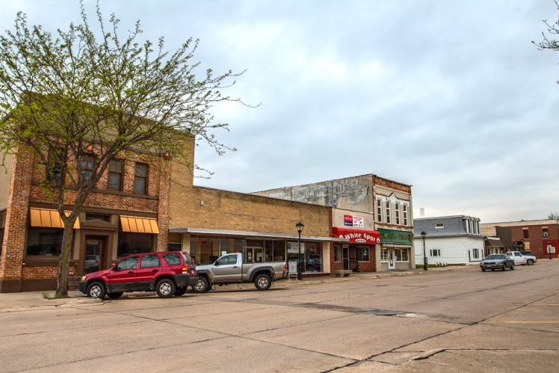

## Continue effective Business Retention & Expansion Program;

Over the past five years, Neligh has seen 42 new businesses with a 77% success rate and 18 transitioned businesses with a 73% success rate. For the City to continue to thrive, it is crucial to continue to work on business retention and recruiting new businesses. To do so, The City and Neligh Economic Development Office should continue to focus efforts on retaining and expanding local businesses through the on-going Business Retention and Expansion (BR&E) program. The program helps maintain relationships with business owners, opens lines of communications between the City, Neligh Economic Development Office, and businesses. The program helps ensure that the Neligh Economic Development Office knows of business owner’s needs, can help recruit employees when needed, could help with any expansion needs, look into possible grant funding, or other development resources, and can assist with succession planning.

## Business Attraction

The Neligh Economic Development Office has established a business attraction strategy that will expand the business stock in the community. The recruitment of these new businesses should be based on the feasibility of the business being successful in the region as well as how it will complement the existing industries, such as the agriculture sector—which is vital to the progress and growth of Neligh. Expanding this sector with complementary businesses could benefit the City and help existing agriculture businesses, and could lead to necessary expansions. The City should also be aware of providing space for the service sector businesses and possible manufacturing or light industrial businesses like grain storage. Targeting areas for prime commercial development should be a focus; this land should have access to a larger transportation network, visibility and land availability, and close to existing corporate limits. The City could also develop an annexation plan of prime commercial real estate and complete a Blight and Substandard Analysis of this real estate.

*This page was intentionally left blank.*